**Support vector machine**

**What is support vector machine ?**

Support vector machine lies in supervised learning algorithm use for classification and regression analysis

**Support vector machine for classification**

**Some terminology**

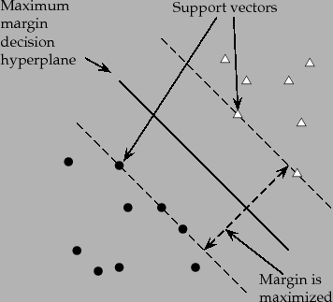

**Margin** is the shortest distance the observation and the threshold and the margin is further divided into soft and hard margin

**Maximum margin classifier** is the optimal hyperplane defined in the (rare) case where two classes are linearly separable.

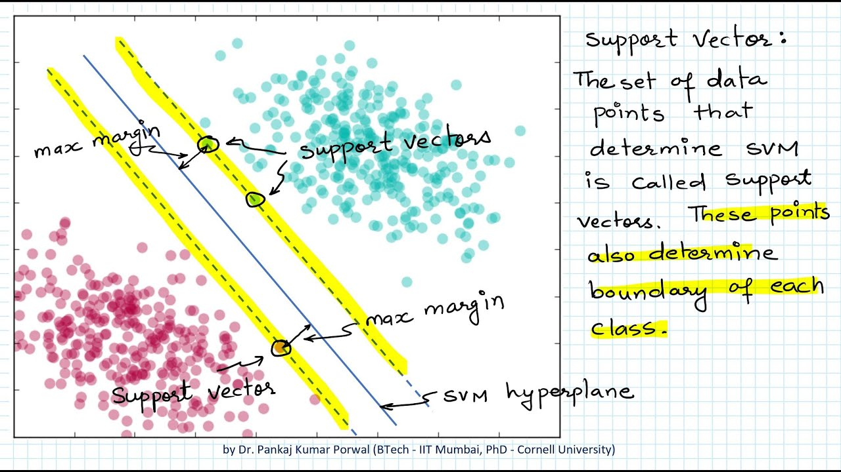

The threshold value is sensitive towards outliers but to remove the sensitivity from outlier of threshold we must all misclassification

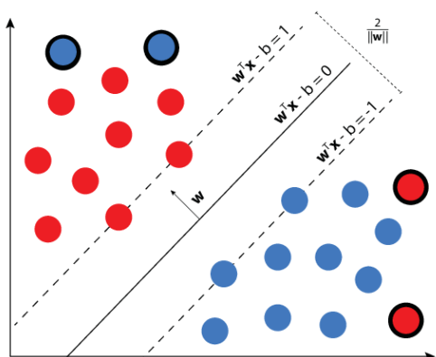

So that’s why we must take threshold that is less sensitive to the training data and allow some misclassification

Difference between **soft margin and hard margin**

When we allow misclassification the distance between the observation and threshold is called  **soft margin**

But we should know how many classification and observation to allow inside of the soft margin to get the best classification

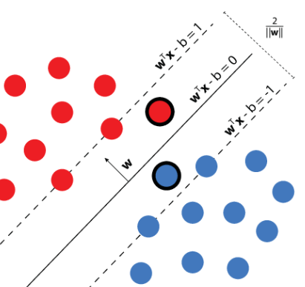

so to do that we use **cross validation**  in order to get best classification

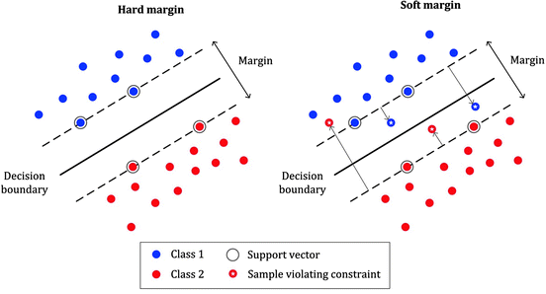

When we use a soft margin to determine the location of a threshold then its called **support vector classifier**

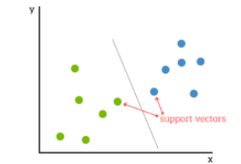

When data is in two dimension then support vector is a **line**  when data is in 3 dimensional then its **plane** then data is in multiple dimension then its called **hyperplane**

But how we can draw line from this data



**What is non linear svm**

We apply svm in which the data is in non linear that in which you can divide data just by straight line for example like this  
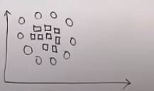

**So to solve this we use kernel function**

**What is kernel function ?**

It take the low dimension space data and convert into high dimension space data

